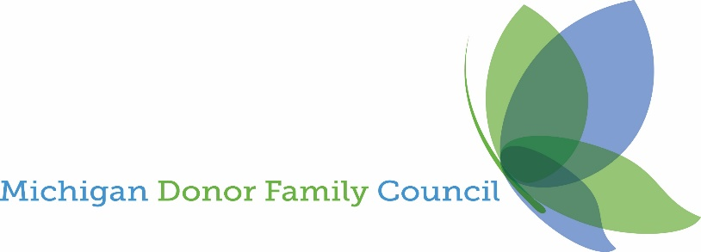

The Michigan Donor Family Council's (MDFC) scholarship program honors individuals touched by the gift of life and advocates of organ eye and tissue donation. The scholarship is available to Michigan organ, eye, and tissue donor family members, living donors, recipients, and advocates of organ, eye, and tissue donation. Annually, we provide scholarships to our community. This year, scholarships are available to two individuals for $2,000 each. The scholarships are available to Michigan high school seniors and current college students who meet the following requirements.

Eligibility Requirements
Applicants must be:
- A donor family member of an individual who donated their organs and tissues in the State of Michigan or
- A Living donor residing in the State of Michigan or
- An organ, eye, or tissue recipient residing in the State of Michigan or
- An advocate of organ, eye, and tissue donation residing in Michigan

Application Process
Applicants must submit the following documentation:
- A typed two-page or fewer document outlining why organ donation is important to you. Include any volunteer work.
- Applicant must be planning to attend an accredited, degree-granting, two or four-year college, University, or vocational/technical school in Michigan during the 2023-2024 school year.

Funding and Distribution
- Awards will be distributed directly to the college or University on the student's behalf.
- Applicant must provide evidence of enrollment to a qualified institution before receiving the award.

Deadline
- Applications should be emailed to pattyjo@mdfc8.org by April 30, 2024.
- The winners will be announced in the second week of May.

Additional Information
An Individual's leadership and commitment to serving their community are recognized.

Questions:
Please send any questions to Patty Jo Herndon at pattyjo@mdfc8.org or 313-549-0415
or visit us at www.Michigandonorfamilycouncil.org.

MDFC family members are not eligible for the scholarship program.

